**EXPERIMENT-15 VM**

SNAPSHOT OF A VM

STEP -1: Create a new Virtual Machine

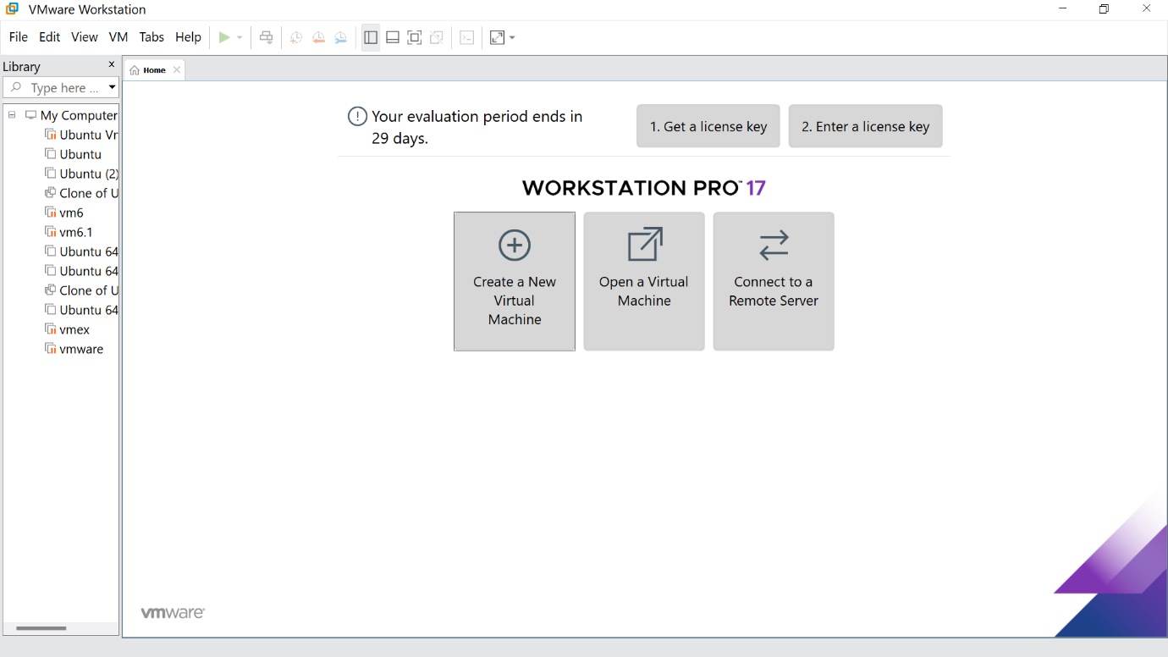

STEP -2: Click on Typical option and click Next

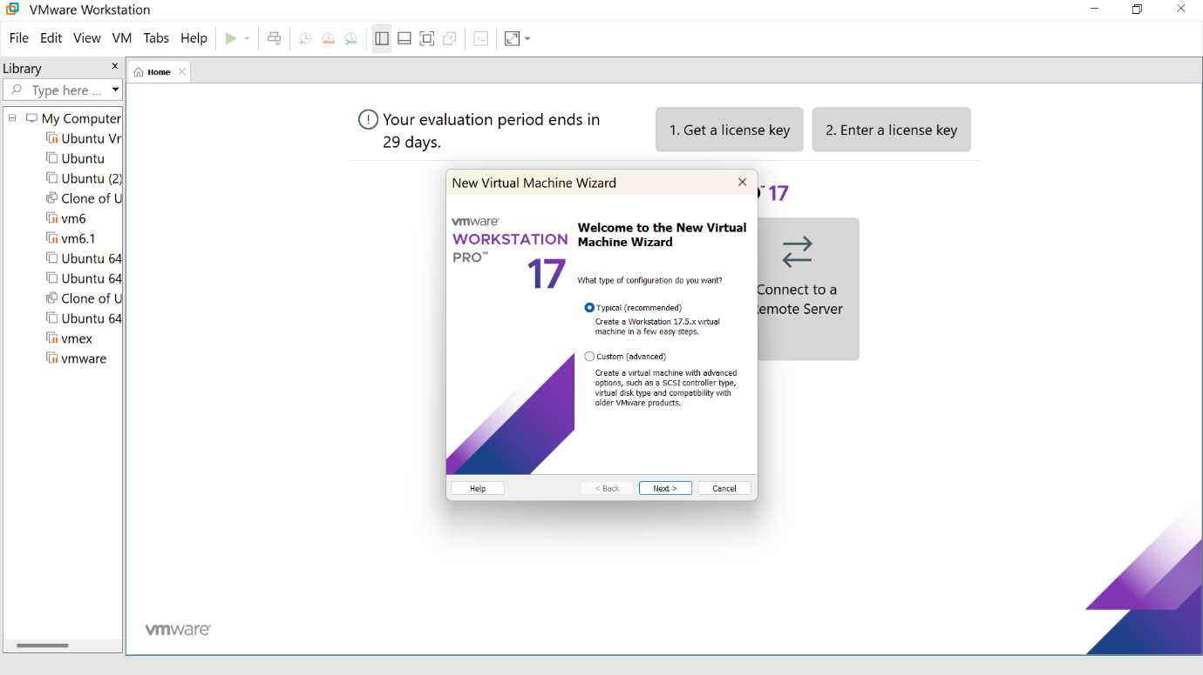

STEP -3: Click the install option and proceed to next step

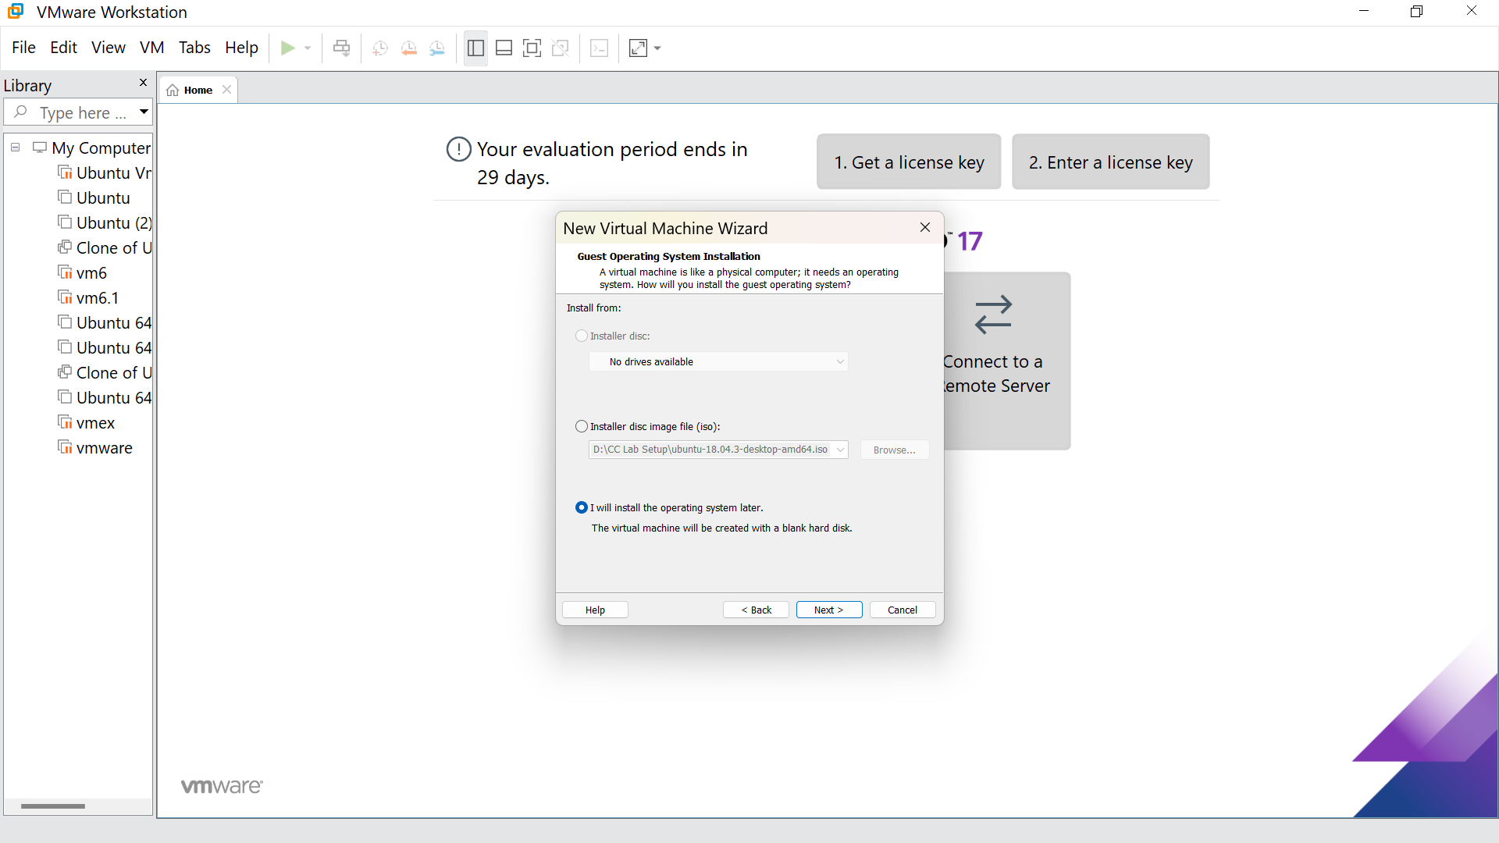

STEP -4: Select Linux option and click Next

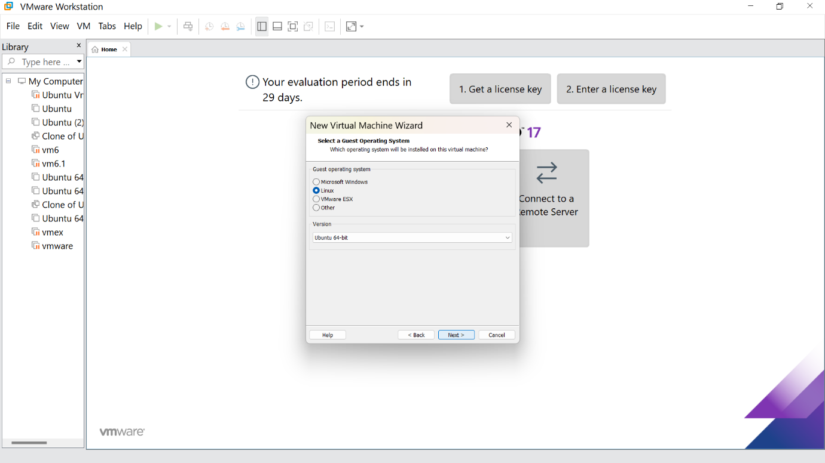

STEP -5: Give the name for the virtual machine(optional) and click next

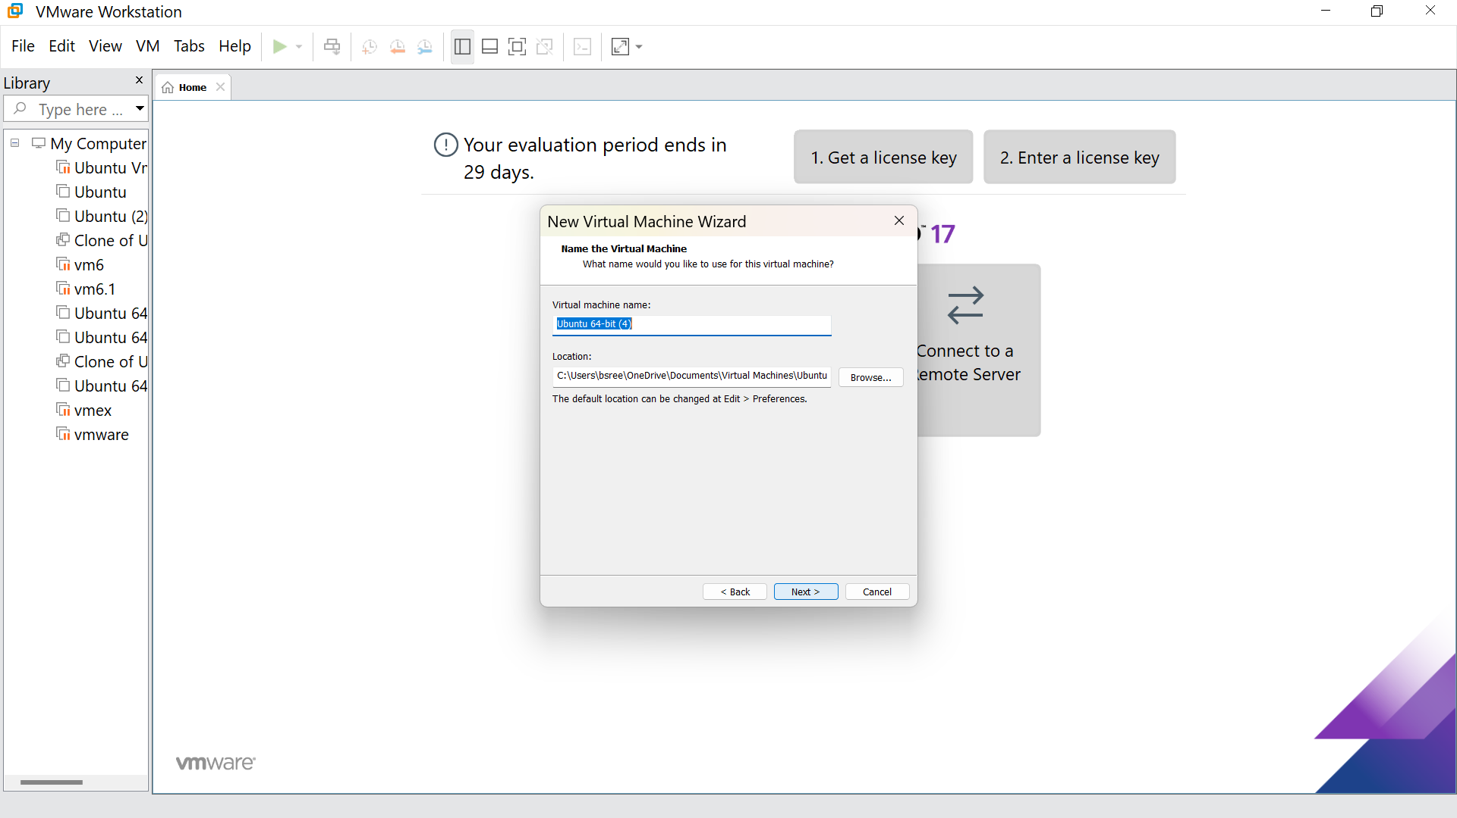

STEP -6: Select the option to store the disk in single file and click next

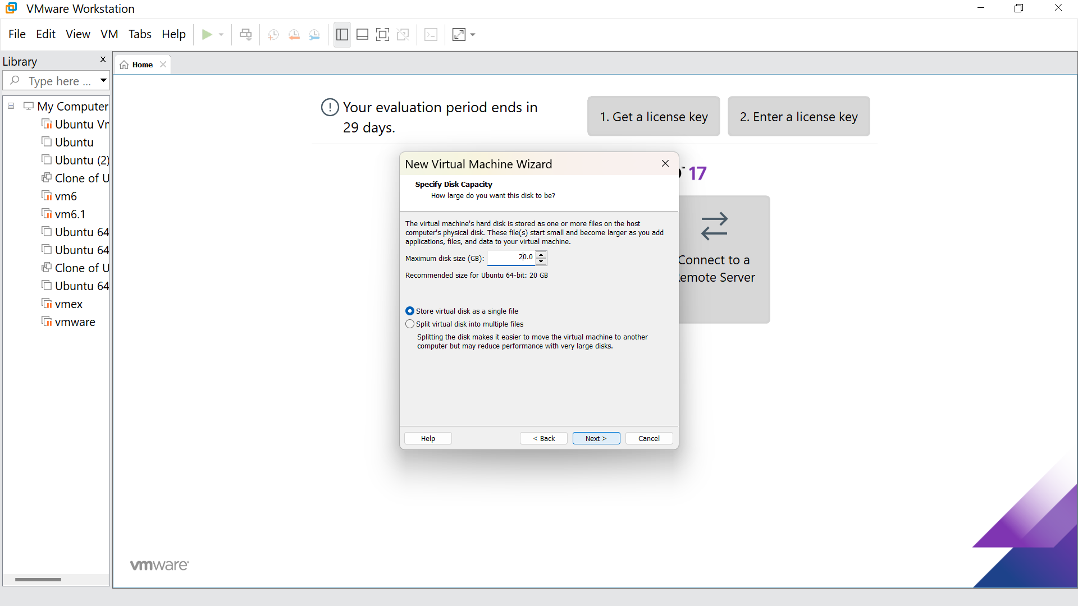

STEP -7: Our new VM is ready ,click finish

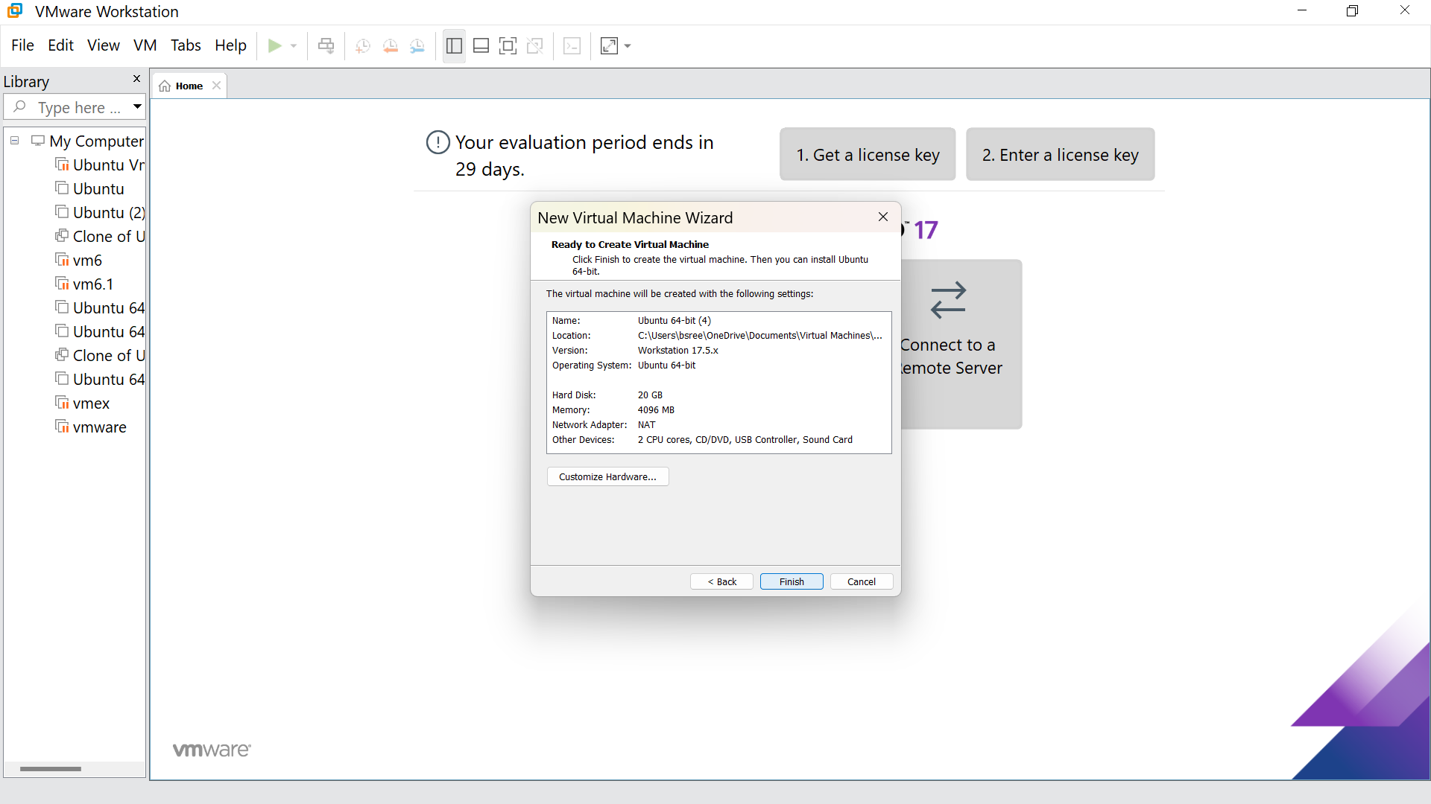

STEP -8: This is the creation of VM

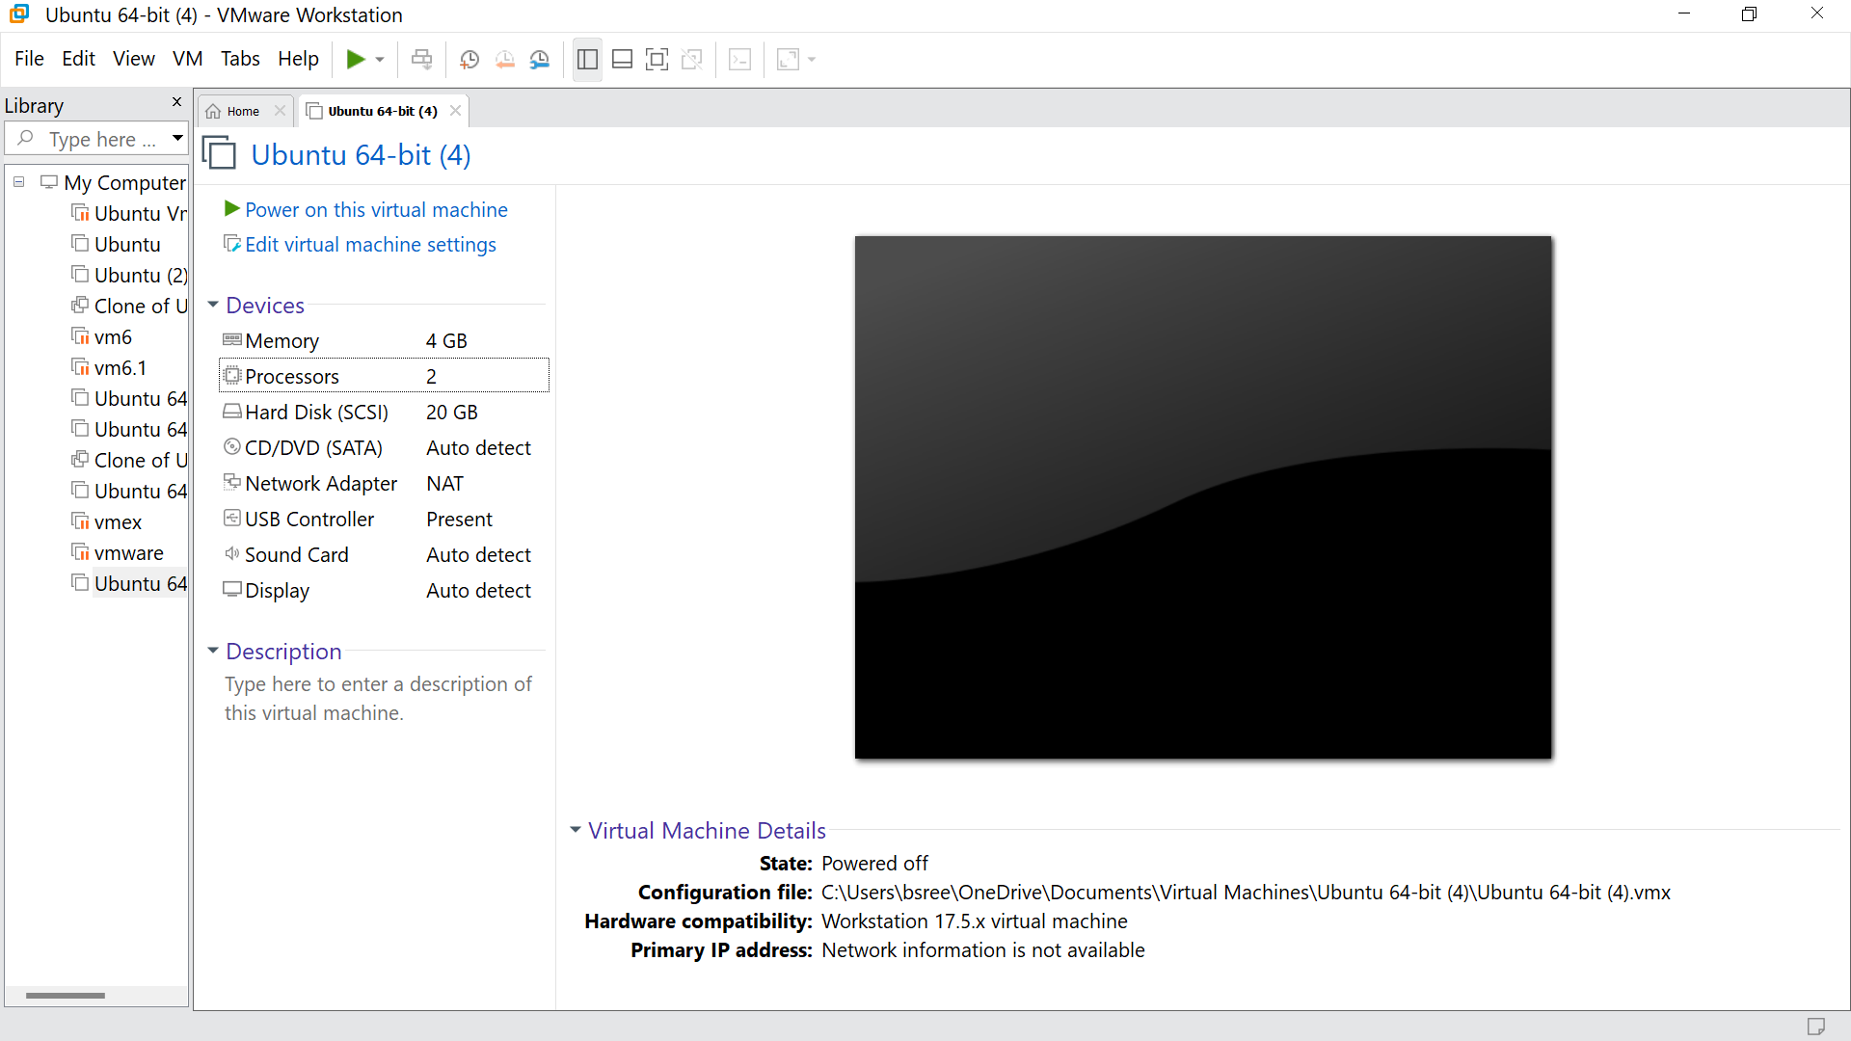

STEP -9: Go to hard disk ,click on add

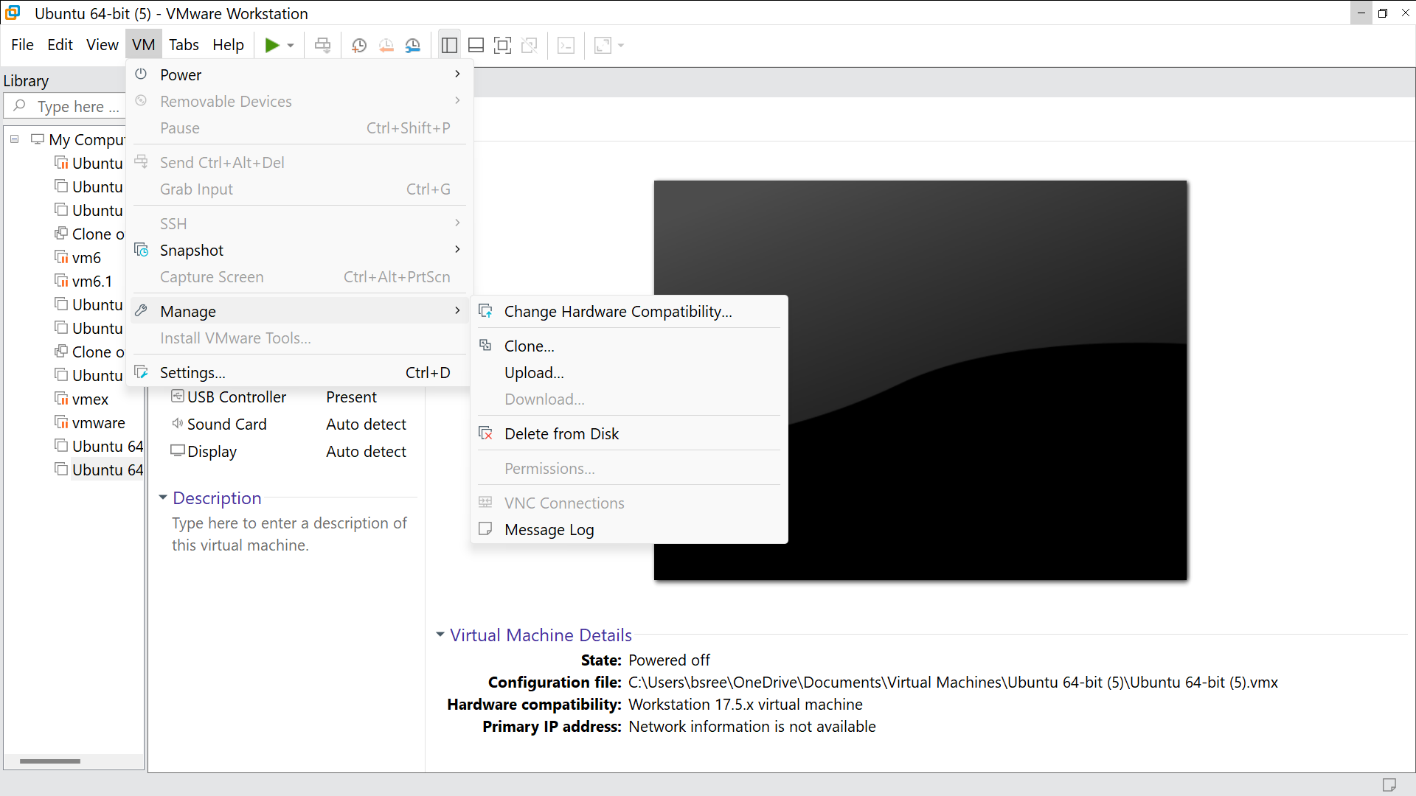

STEP -10: GO to clone and Click Next

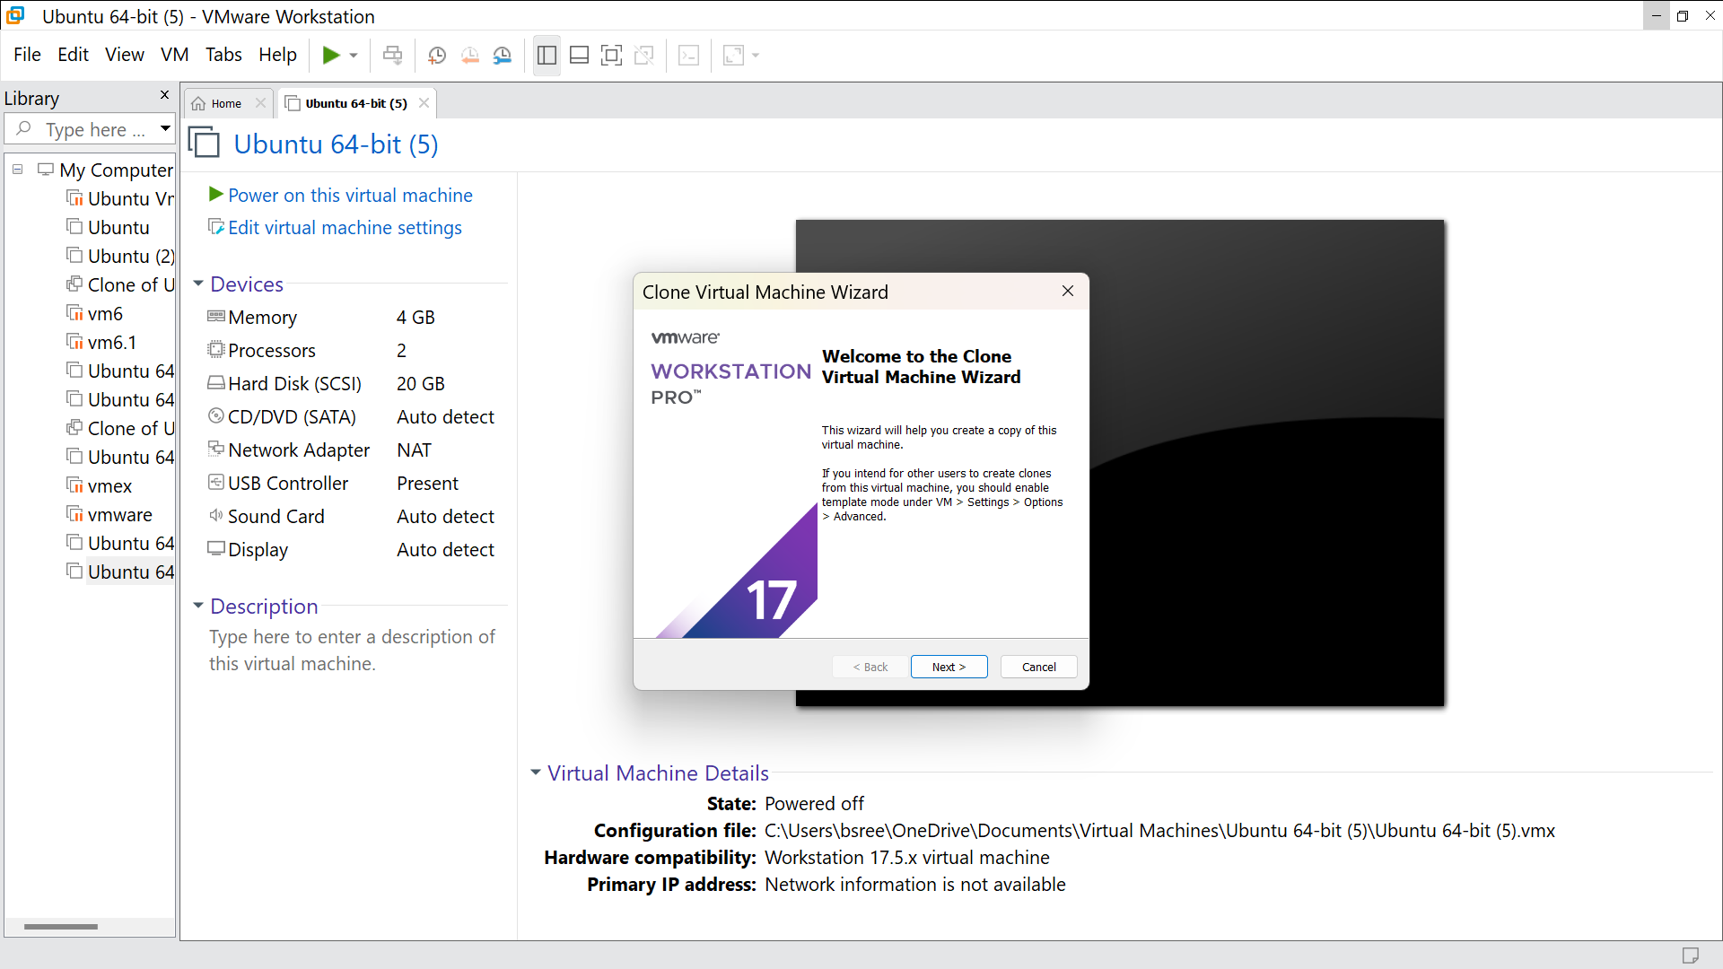

STEP -11: Click the optin called ‘Current state in the virtual system’ and click next

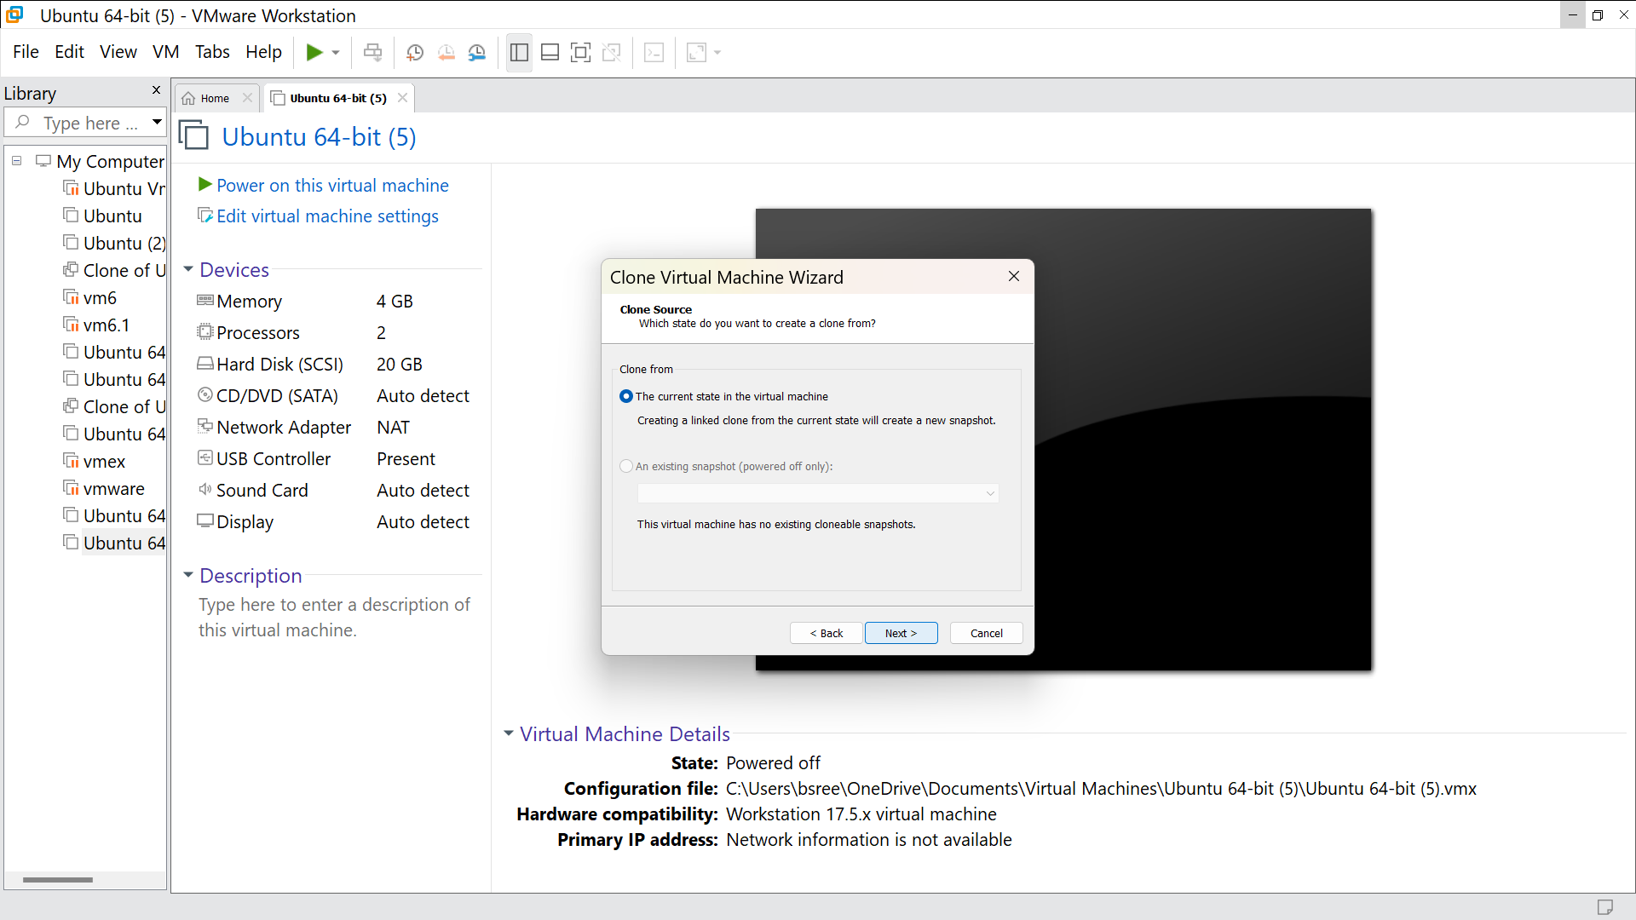

STEP -12: Click on ‘Create a linked clone’ and click next

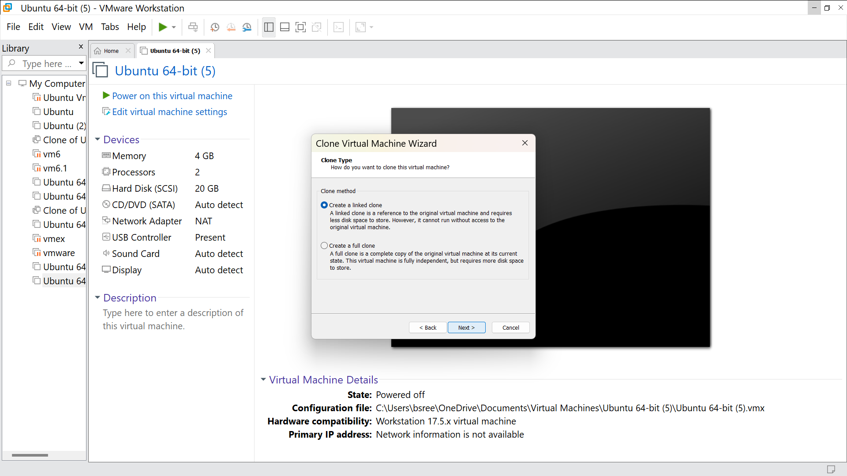

STEP -13: Change the virtual machine name and click finish

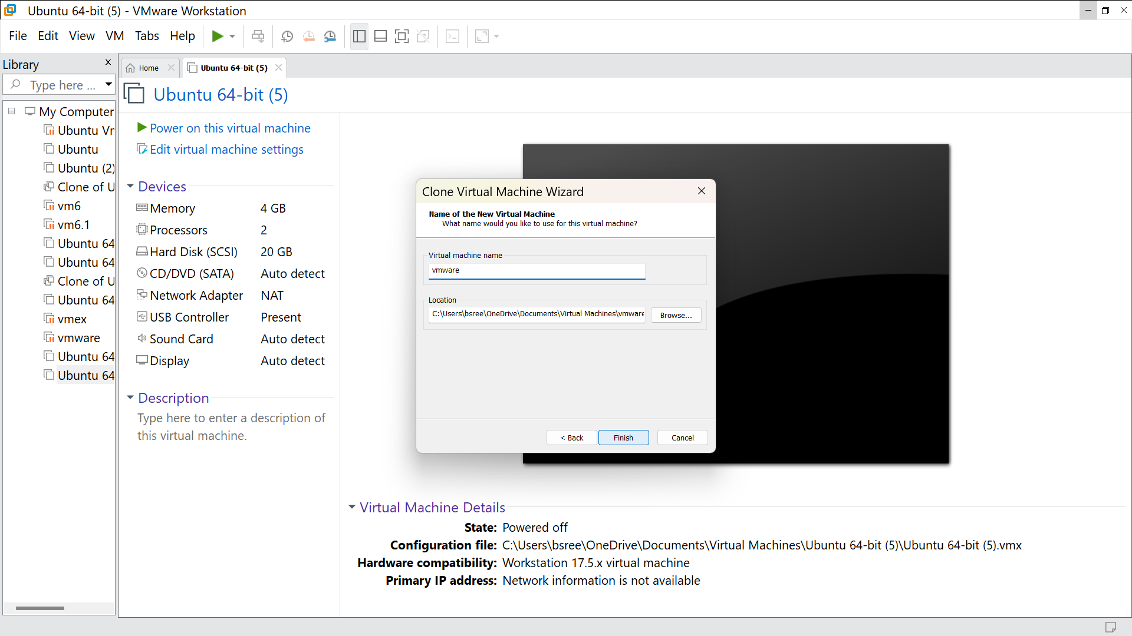

STEP -14: Click close

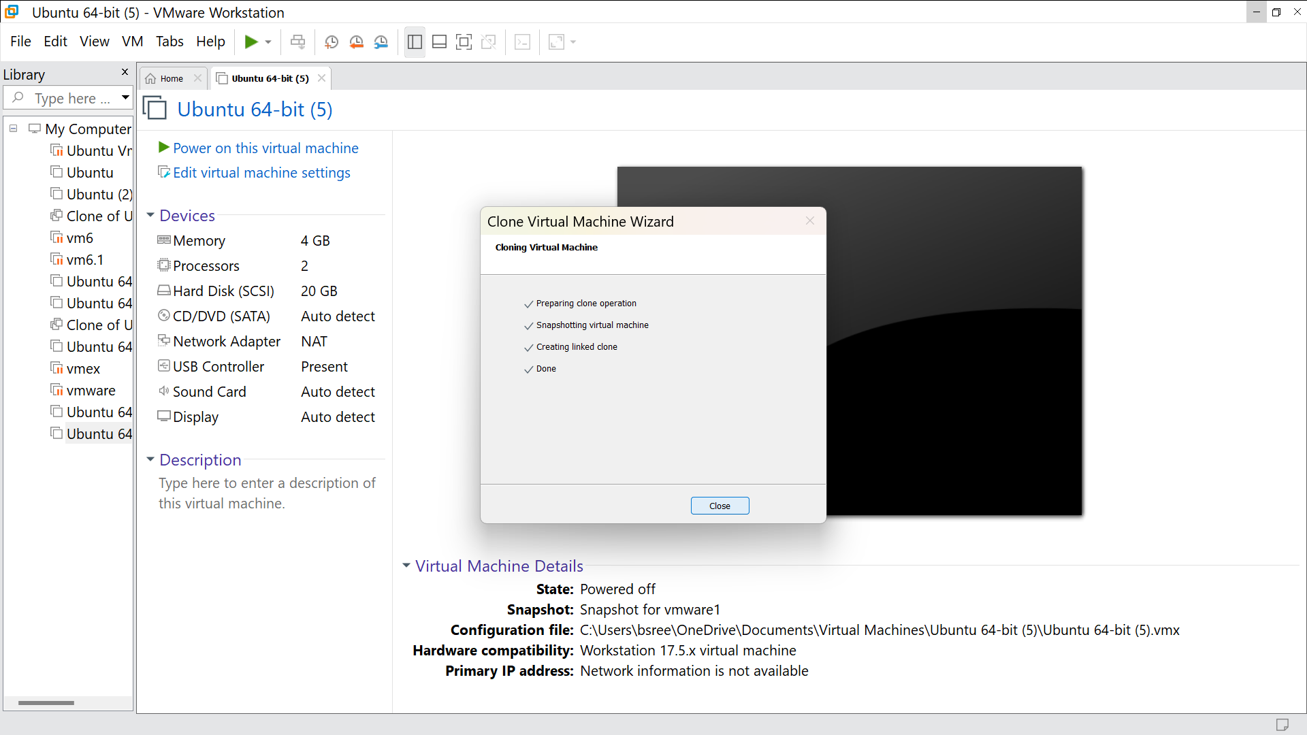

STEP -15: It is cloned

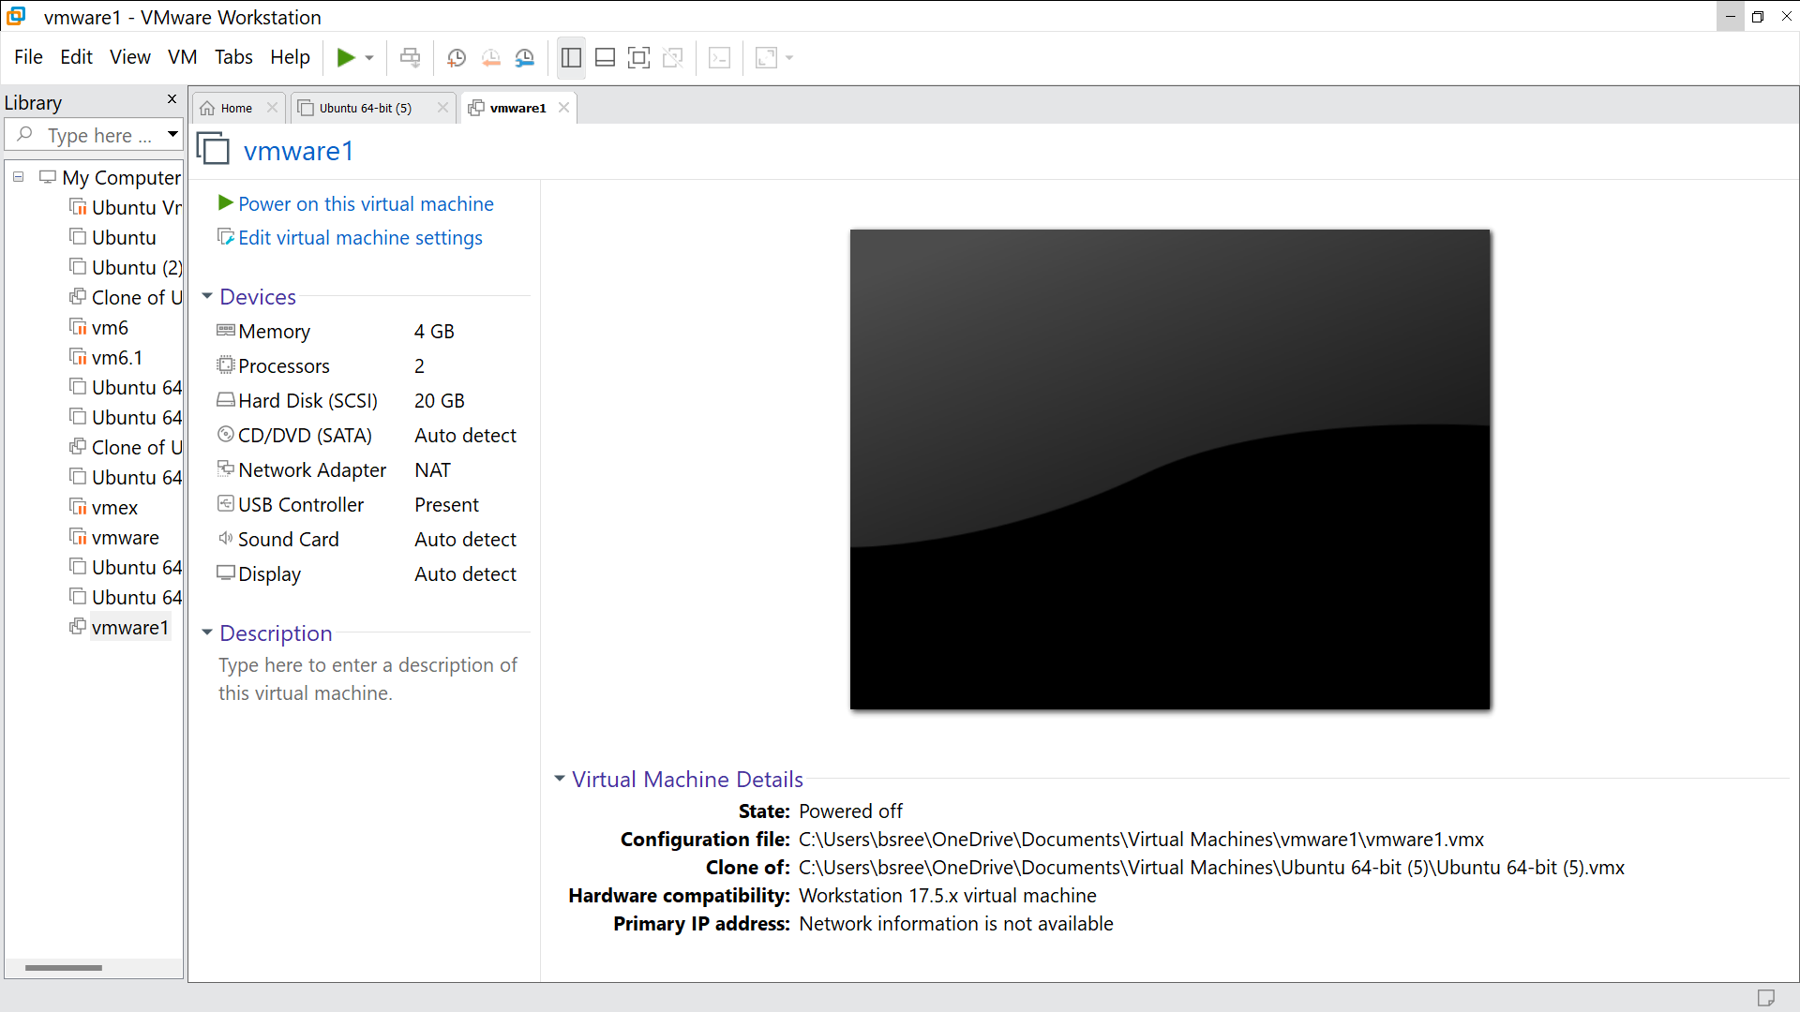

STEP -16: Go to VM and go to snapshot, click it

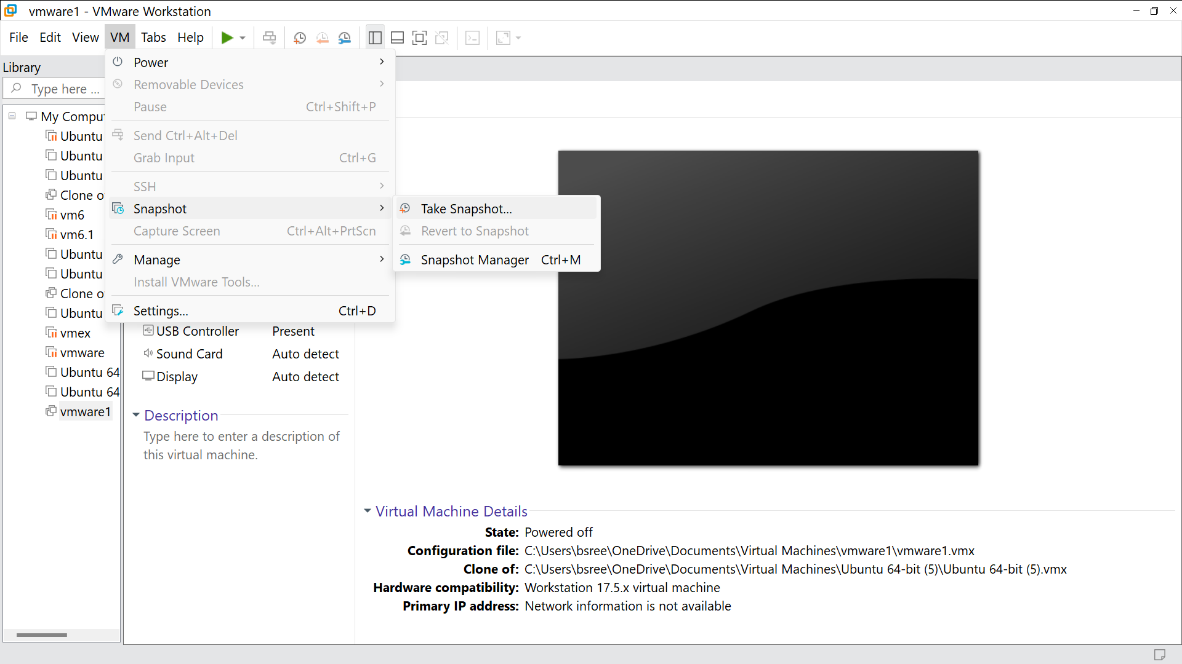

STEP -17: Click on take snapshot

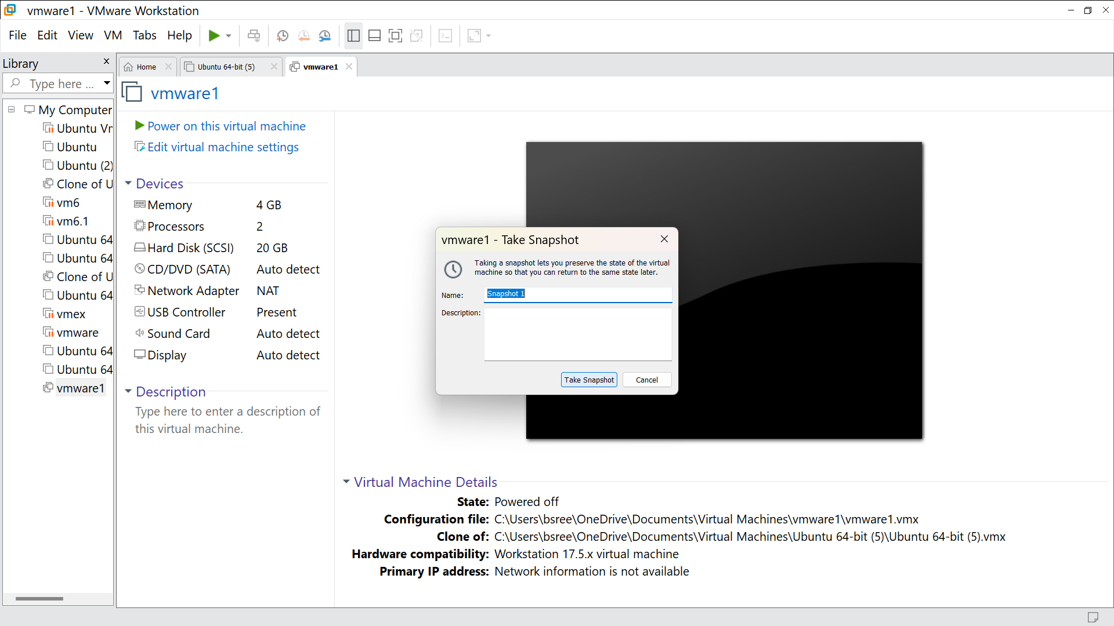

STEP -18: Run it and this will be the output

